Recipe Manager User Manual

Introduction

Welcome to the Recipe Manager! This application allows you to easily manage your recipes, ingredients, and menus. With an intuitive interface, you can add, view, and filter recipes, as well as calculate total calories for each recipe. This guide will walk you through the features and functionalities of the application.

Getting Started

Launching the Application

1. Install and Open: Install the Recipe Manager application on your computer and open it.

2. Main Window: You will be greeted with the main window, which has sections for adding recipes, viewing recipes, viewing recipe details, filtering recipes, and creating menus.

Main Features

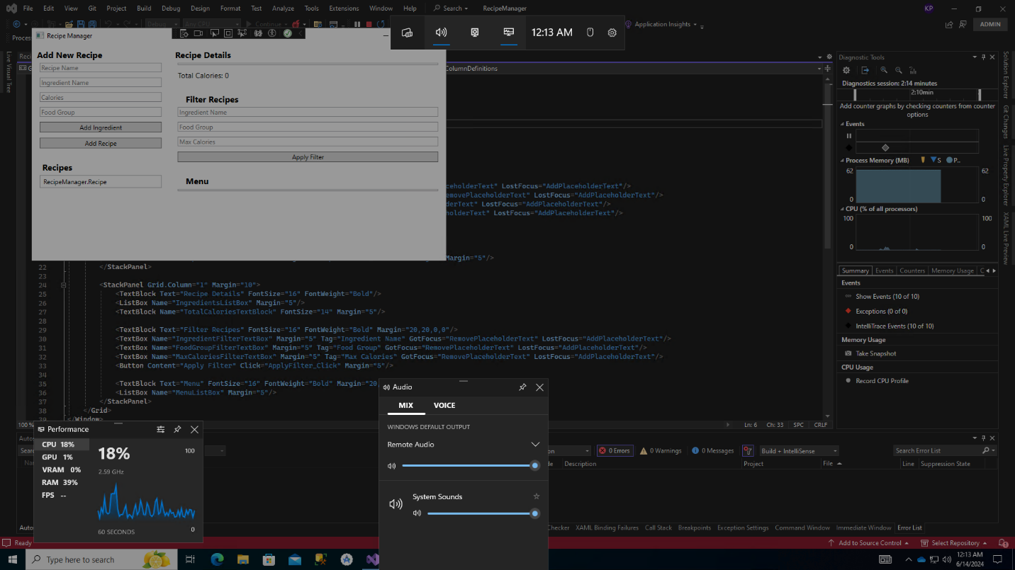

Adding a Recipe

1. Enter Recipe Name:

- Locate the "Enter recipe name" text box at the top of the window.

- Click on the text box, and type the name of your recipe.

- Example: "Chocolate Cake"

2. Add Recipe:

- Click the "Add Recipe" button next to the text box.

- The recipe will be added to the list on the left side of the window.

Viewing Recipes

1. Recipe List:

- The left side of the window displays the list of recipes.

- Recipes are sorted alphabetically by name.

2. Select a Recipe:

- Click on a recipe name in the list to view its details.

- The ingredients and total calories for the selected recipe will be displayed in the middle section of the window.

Viewing Recipe Details

1. Ingredients List:

- When a recipe is selected, its ingredients are listed in the middle section of the window.

- Each ingredient's name, calories, and food group are displayed.

2. Total Calories:

- The total calories for the selected recipe are shown at the bottom of the ingredients list.

Adding Ingredients to a Recipe

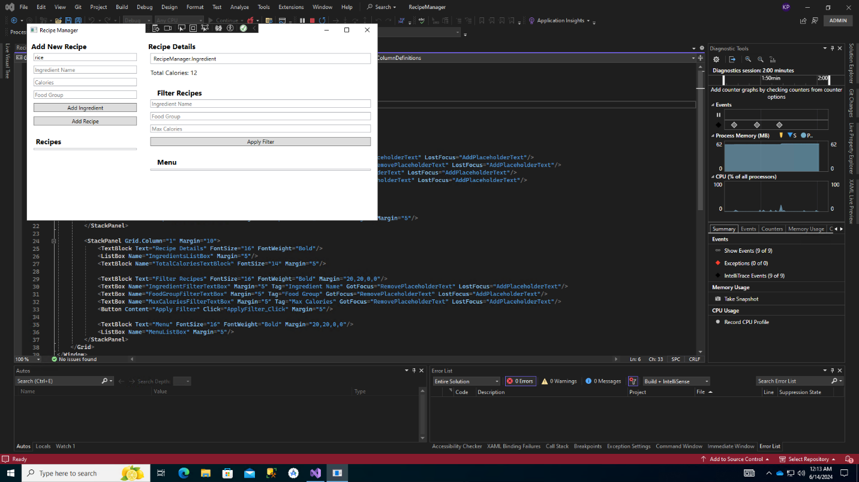

1. Select Recipe:

- Click on a recipe from the recipe list to select it.

2. Enter Ingredient Details:

- Enter the ingredient name, calories, and select the food group in the middle section of the window.

3. Add Ingredient:

- Click the "Add Ingredient" button to add the ingredient to the selected recipe.

- The ingredient will appear in the ingredients list, and the total calories will be updated.

Filtering Recipes

1. Filter by Ingredient:

- Enter the name of an ingredient in the "Ingredient" text box under the "Filter Recipes" section on the right.

- Click the "Apply" button to filter recipes containing the specified ingredient.

2. Filter by Food Group:

- Select a food group from the drop-down menu under the "Filter Recipes" section on the right.

- Click the "Apply" button to filter recipes containing ingredients from the specified food group.

3. Filter by Calories:

- Enter the maximum number of calories in the "Max Calories" text box under the "Filter Recipes" section on the right.

- Click the "Apply" button to filter recipes with total calories less than or equal to the specified amount.

Creating a Menu

1. Select Multiple Recipes:

- Hold down the `Ctrl` key and click on multiple recipes from the recipe list to select them.

2. Create Menu:

- Click the "Create Menu" button at the bottom right of the window.

- The selected recipes will be combined into a menu.

Additional Tips

Placeholder Text

- Placeholder text (e.g., "Enter recipe name", "Ingredient", "Max Calories") will appear in text boxes when they are empty.

- Click on a text box to remove the placeholder text and enter your data.

- If you click out of the text box without entering any data, the placeholder text will reappear.

Managing Ingredients

- You can add multiple ingredients to each recipe.

- Ensure that each ingredient has a unique name within the same recipe to avoid confusion.

Sorting Recipes

- Recipes are automatically sorted alphabetically by name when they are added to the list.

Troubleshooting

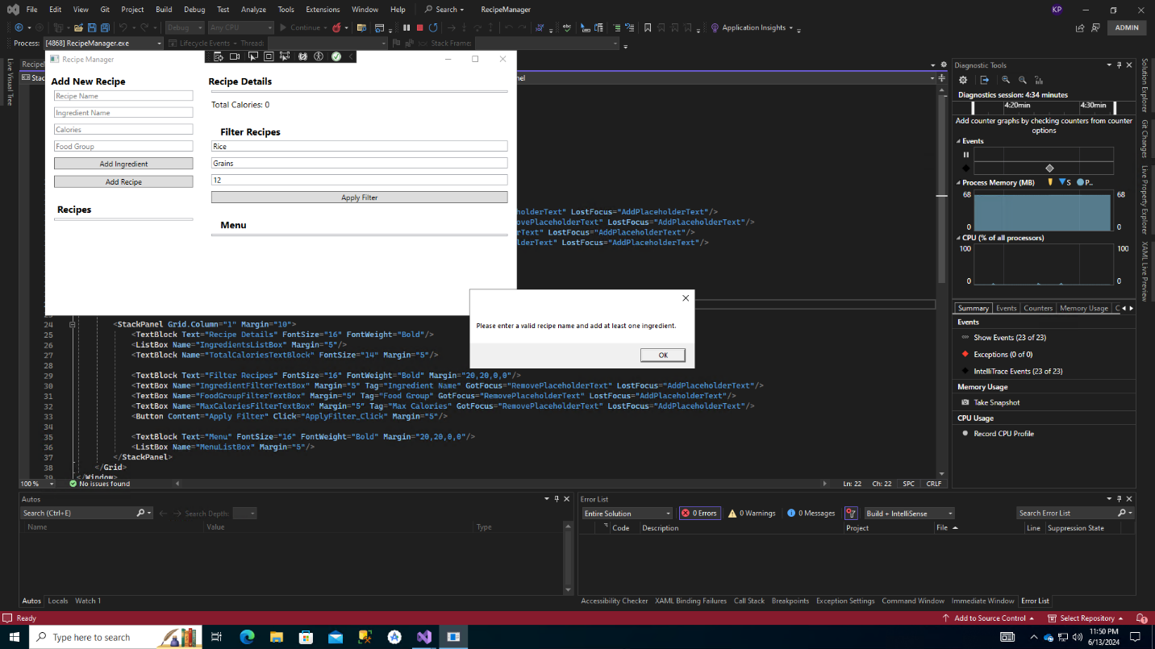

No Recipes Displayed

- Ensure that you have added recipes correctly by entering a name and clicking the "Add Recipe" button.

Filters Not Working

- Make sure that the filter criteria are correctly entered.

- Check that the ingredient or food group exists in the recipes.

- Ensure that the maximum calories filter is set to a reasonable value.

Conclusion

The Recipe Manager application is designed to help you organize and manage your recipes efficiently. By following this user manual, you should be able to navigate and use the application with ease. Happy cooking!